BCT Assignment 3
Neeti Kurulkar
Smart Contract for a Bank Account on a Test Network

Code:

// SPDX-License-Identifier: MIT
pragma solidity ^0.8.0;

contract Bank {
// Mapping from user address to their balance
mapping(address => uint256) private balances;

// Deposit money into your account
function deposit() public payable {
require(msg.value > 0, "Deposit must be greater than 0");
balances[msg.sender] += msg.value;
}

// Withdraw money from your account
function withdraw(uint256 amount) public {
require(amount > 0, "Withdrawal must be greater than 0");
require(balances[msg.sender] >= amount, "Insufficient balance");

// Deduct balance first (checks-effects-interactions pattern)
balances[msg.sender] -= amount;

// Transfer Ether back to the user
payable(msg.sender).transfer(amount);
}

// Show your current balance
function showBalance() public view returns (uint256) {
return balances[msg.sender];
}
}

Output:

- Upload Code on Remix IDE

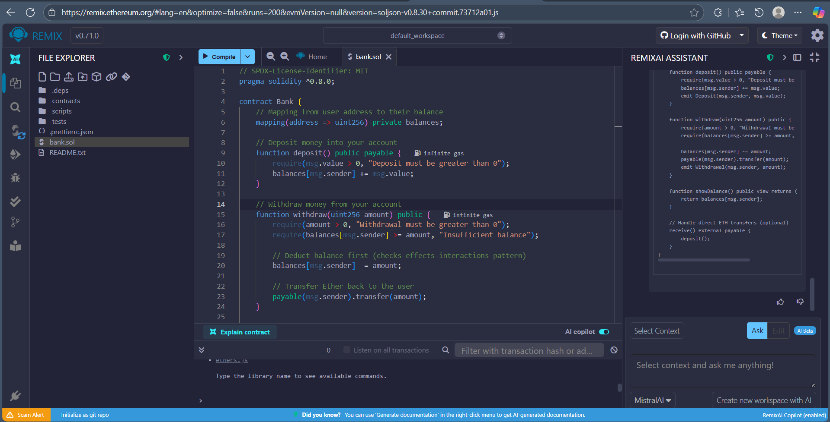

- Connect MetaMask Wallet

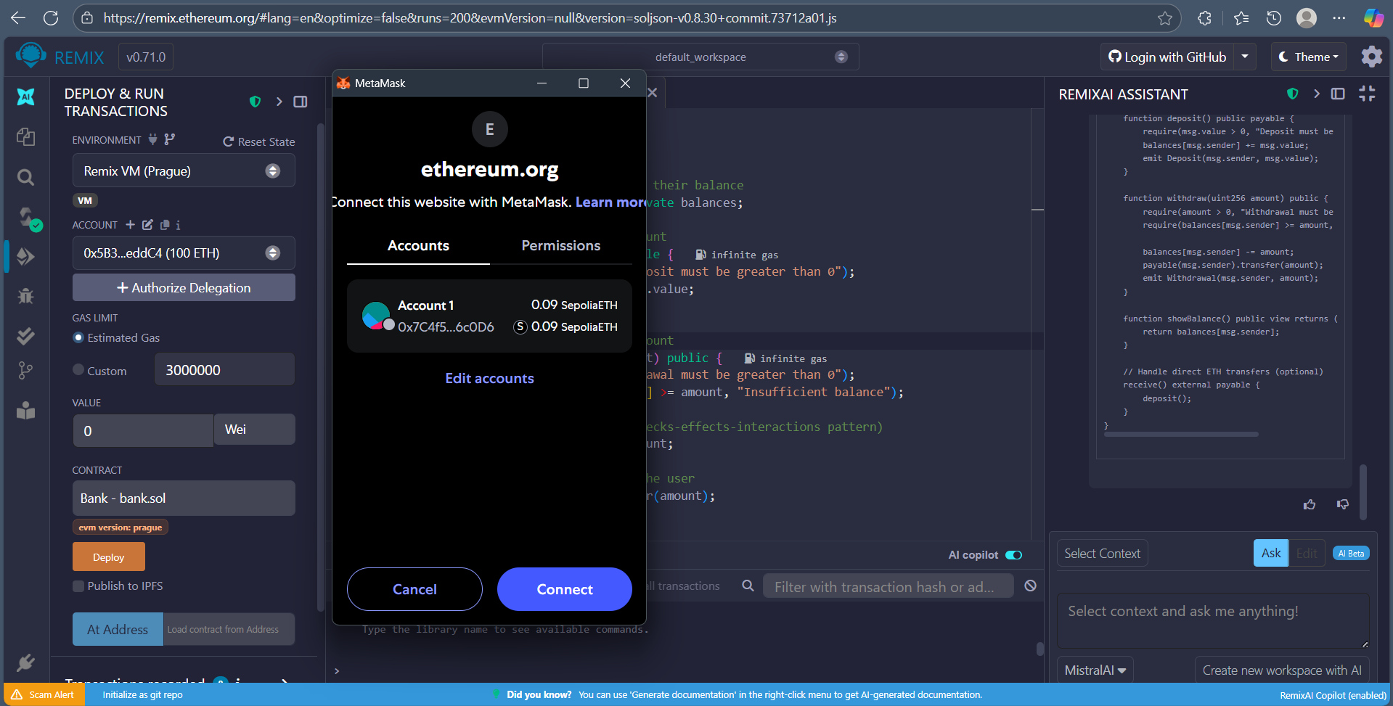

- Deploy Contract
